**Data Manager - User Manual**

Table of Contents

1.0 Purpose 3

2.0 Scope 3

**3.0 Dashboard………………………………………………………………………………………………………………………3**

3.0 CRDR Modules 3

4.0 User Workflows 4

4.1 Study Dashboard 4

4.2 Study Documents 6

4.3 Query List 8

4.4 Standard Reports 18

4.5 Data Extraction 21

4.6 User Profile Setup and Administration 25

4.7 Audit Log 26

4.8 Lock Study / Site 28

4.9 Create Sites 28

4.10 Medical Coding 30

4.11 Admin Tasks 34

5.0 Help Desk 35

# Purpose

This user manual provides an overview of CRDR- Clinion- Clinical Trial Solution, modules, and data management workflow. This manual provides guidelines for the Data Manager to use CRDR- Clinion platform.

# Scope

The scope of this manual is limited to describing the system functionalities and related workflows for Data Manager.

# CRDR Modules

The following modules are available to Data Manager:

* Study Dashboard
* Study Documents Repository
* Query Management Module
* Standard Reports
* Data Loader
* Data Extraction
* User Profile Set-up & Administration
* Audit Log
* Lock Study or Site
* Create Site
* Medical Coding
* Admin Tasks
* Help Desk

# 

# User Workflows

## 4.1 Study Dashboard

* Data Manager is directed to Study Dashboard on login.

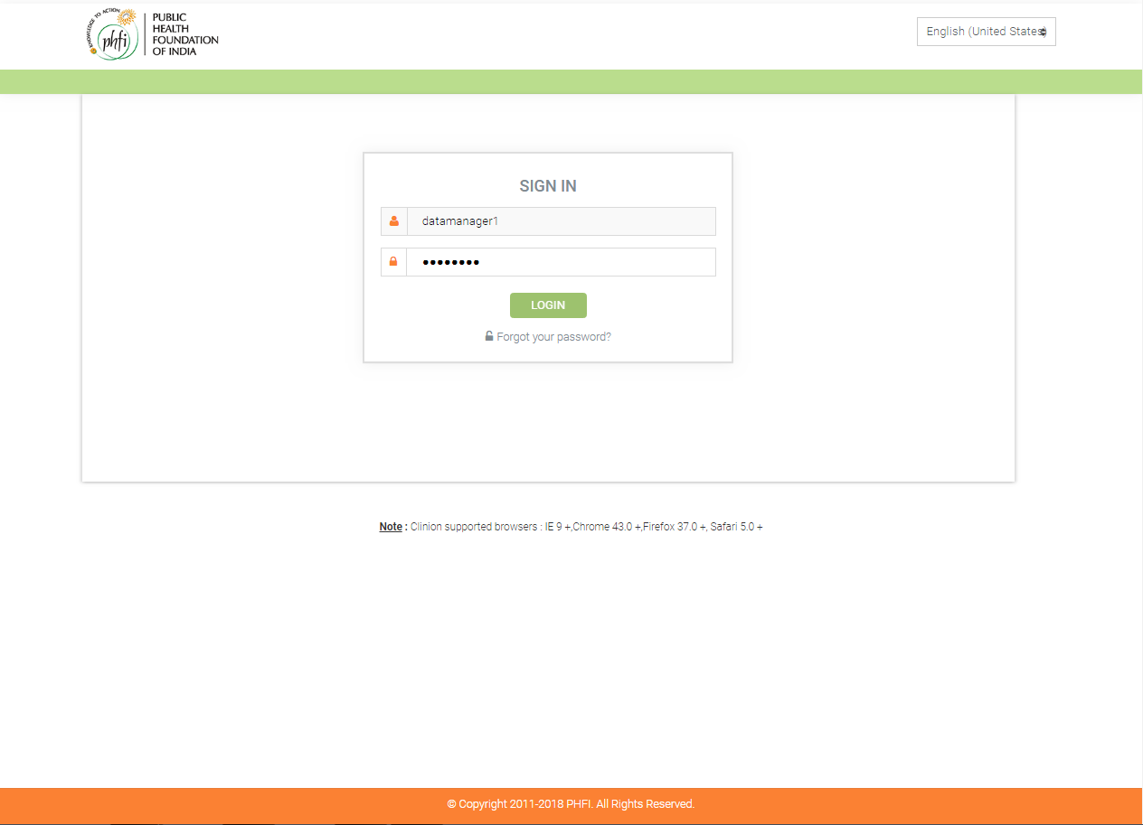

Data Manager’ Login Page

* After logging in, the data manager is directed to the Dashboard which has graphs and tables representing the vital information of the various sites.
* In Clinion, there’s a specific color coding followed to represent the study completion status of subjects enrolled in the study. This color coding is 21 CFR Part 11 validated.

1. Orange color – N**ot started yet** the study.
2. Blue color – I**n progress**.
3. Red color – **Excluded** from the study.
4. Green color – **Completed** the study.
5. Black/Grey color – **Withdrawn** from the study.

* The data manager can find the following information in the dashboard:

1. **Subject Count:** This gives the total count of subjects that are In Progress and the one’s that have Completed the study. With the mouse over, the data manager can see the number of subjects for all the aforementioned study status categories. In the center of this chart, the data manager can see the cumulative count of the subjects who are in progress and those who have completed the studies.
2. **Enrollment Status:** Represents the Subjects under each status of the study, for every site. When the mouse over is done, the data manager can see the total count of subjects along with the Site ID. When the mouse over is done on, it would give the count of subjects along with the Site they belong to. The data manager can scroll towards the right to see the enrollment status of all the sites.

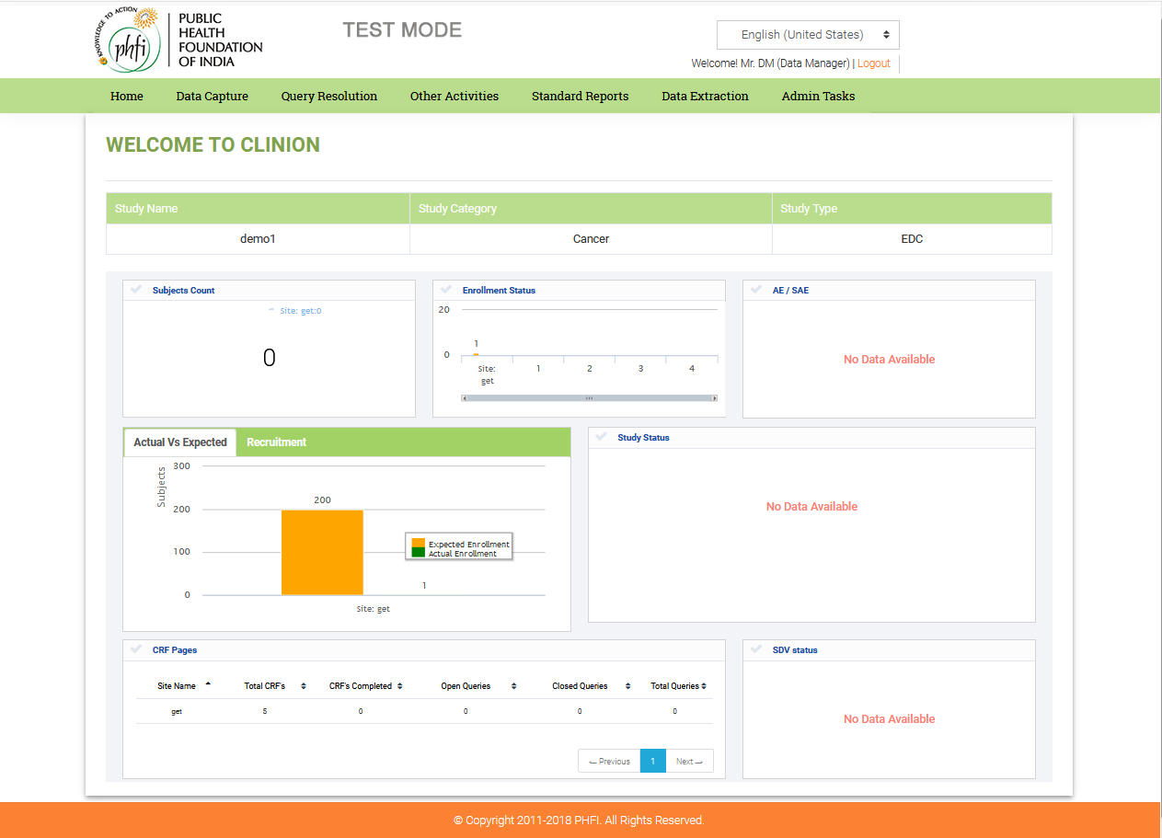

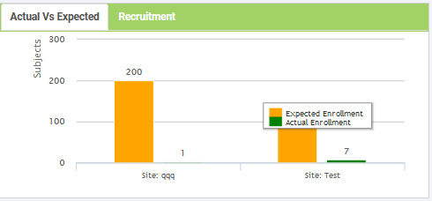

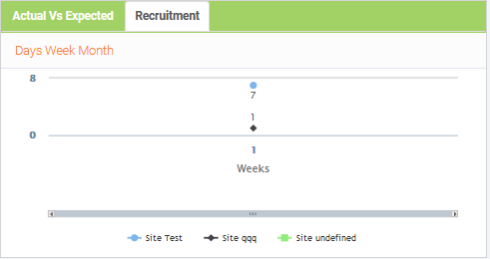

Datamanager’s Dashboard

1. **AE/SAE:** This graph would give the number of Adverse Events and Serious Adverse Events recorded, per site. The data manager can scroll towards the right to see the number of sites and the AE’s and SAE’s. With mouse over, the data manager can see the count of AE/SAE recorded, per site.
2. **Actual Vs Expected:** Actual Vs expected gives you the details about total no. of actual subjects and exact enrollment that happened in the site.

**Recruitment:** In this graph, the data manager can see the number of subjects enrolled per site, in every week. When the mouse is over any point in the graph, it would give cumulative data of the subjects enrolled until that point, along with the total number of weeks. At the bottom of the graph, the data manager can see the Site numbers represented in different colors. If the data manager clicks on any site, the recruitment status of that particular site, alone, would be displayed. The details can be viewed in Days , Weeks and Month wise format. On clicking on respective “Day” or “week” or “ Month” menu the results will vary.

1. **Study Status:** This graph Subjects vs. Visits Completed. It represents the total number of subjects that have completed their visits per site. With mouse over any of the bars in the graph, the datamanager can see the Visit name, number and the number of subjects that have completed that particular visit. Each visit would be coded in a different color. On scrolling towards the right, the data manager can see the visits completed by subjects, in different sites.
2. **CRF Pages:** Information on the CRF pages completed per site, Open Queries, Closed Queries and the Total number of Queries, can be seen under CRF pages.
3. **SDV Status:** With mouse over, the datamanager can see the total number of subjects that have been source data verified, along with the site numbers.

* The modules that are accessible to Data manager are enabled in the header and footer and the rest of the modules are disabled.

## 4.2 Study Documents(Other activities)

**Features:**

* Multiple study documents can be uploaded quickly and accessed over the web.
* Easy Retrieval/Download of Study related Documents.

**Workflow:**

* In the home page, Other Activities click on study documents in the menu.

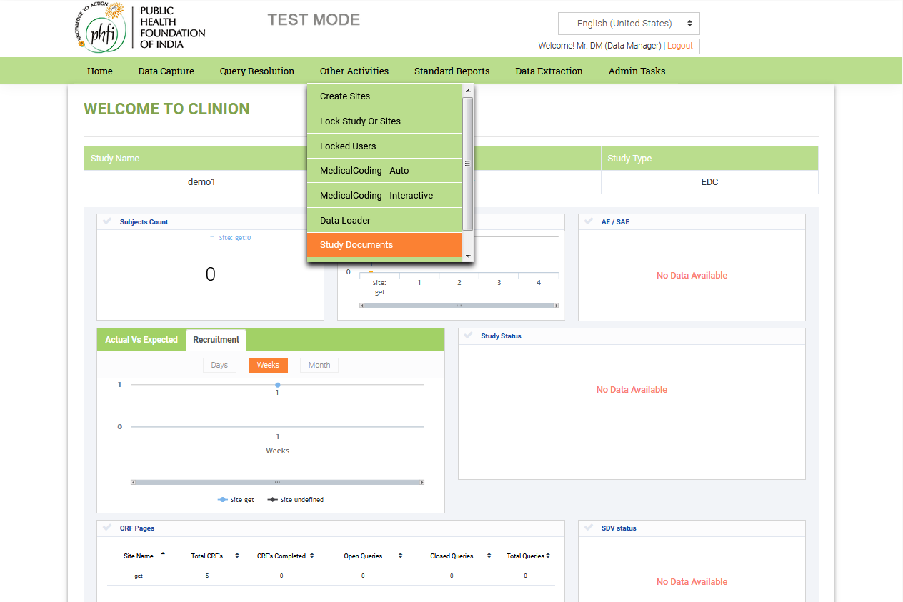

3.1: Study Documents

* The Study documents page is displayed. It provides the data manager with the option to upload Study related documents, into the application. In Add Document, the data manager can Browse and attach the document, enter a Title for the document and choose the Version (Major or Minor). Once the file is attached, the data manager would click on the Submit button.

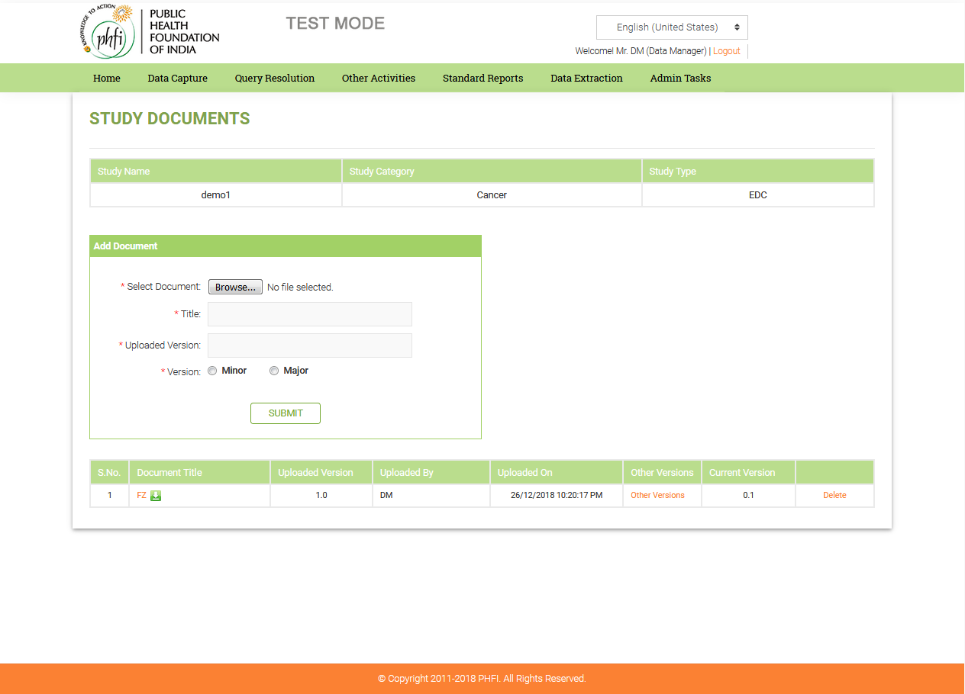

3.2: Study Documents

* The details of the attached file can be seen below, once it is saved. The following details would be presented in the table below Add document, which would have the following details:

1. S. No.
2. Document Title
3. Current Version
4. Uploaded By (username)
5. Uploaded On
6. Other Versions (link): When the data manager clicks on this link, a small page would appear which would have details like, Document title, Version, Uploaded by, Uploaded on (date and time), Delete option.
7. This document title would have the download file icon next to it. The data manager can view the files or download them by clicking on this icon.

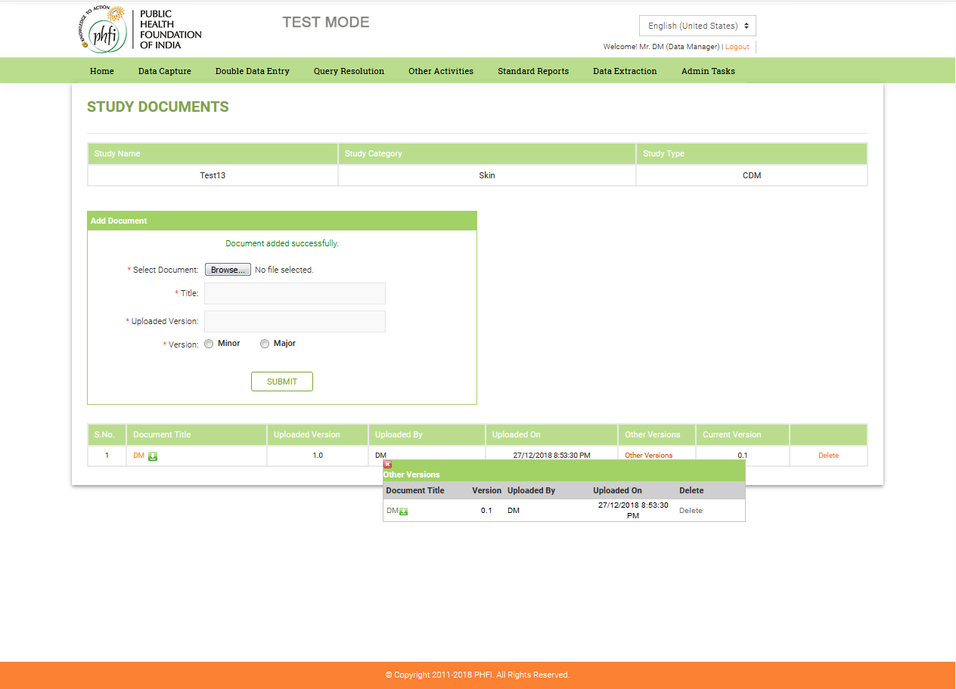

Figure 3.3: Study Documents

## 4.3 QUERY Resolution (Query LIST)

**Features:**

* Robust Query management system where Automated Queries are generated for data values out of range or those that have failed to meet the predefined edit check of Data item.
* Manual queries can be raised by Data Manager and assigned to Investigator or other site level personnel.
* The Data Manager can view the list of queries generated in the query list provided under the Query List tab.
* The Data Manager can raise a Manual query which would direct to the page where queries can be raised.

**Workflow:**

* The Data manager clicks on the “Query List” under the “Query List” menu item in the header to navigate to the Query List page.
* The Query List page contains the following sections:
  1. Filter (Site ID, Subject ID, Visit Name, Status of Query, All Queries (irrespective of the site))
  2. Query List
  3. Query List Activities
* The Data manager can use filter options available in the first section to refine the queries as per the below criteria.
  1. Site Id
  2. Subject Id
  3. Visit Name
  4. Status
  5. All Queries / Queries assigned to me.

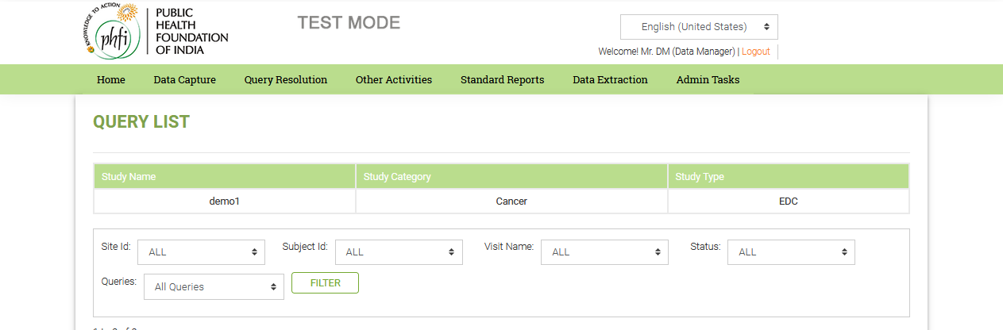

Figure.4: Query List

* The Query list section contains list of queries with the following attributes
  1. Site Id
  2. Batch Id
  3. Subject Id
  4. Visit
  5. Page
  6. Item Name
  7. Query Title
  8. Status
  9. Assigned To
  10. Raised By
  11. Query Manager
  12. Posted On
  13. QRS Id
  14. Source Data Link
* The following color codes are displayed for the queries in the query list based on their statuses.
  1. New – Red
  2. Resolution Proposed – Orange
  3. Updated – Grey
  4. Closed – Green
* The Data Manager can click on the query title to open the individual query and can view the query in-detail.

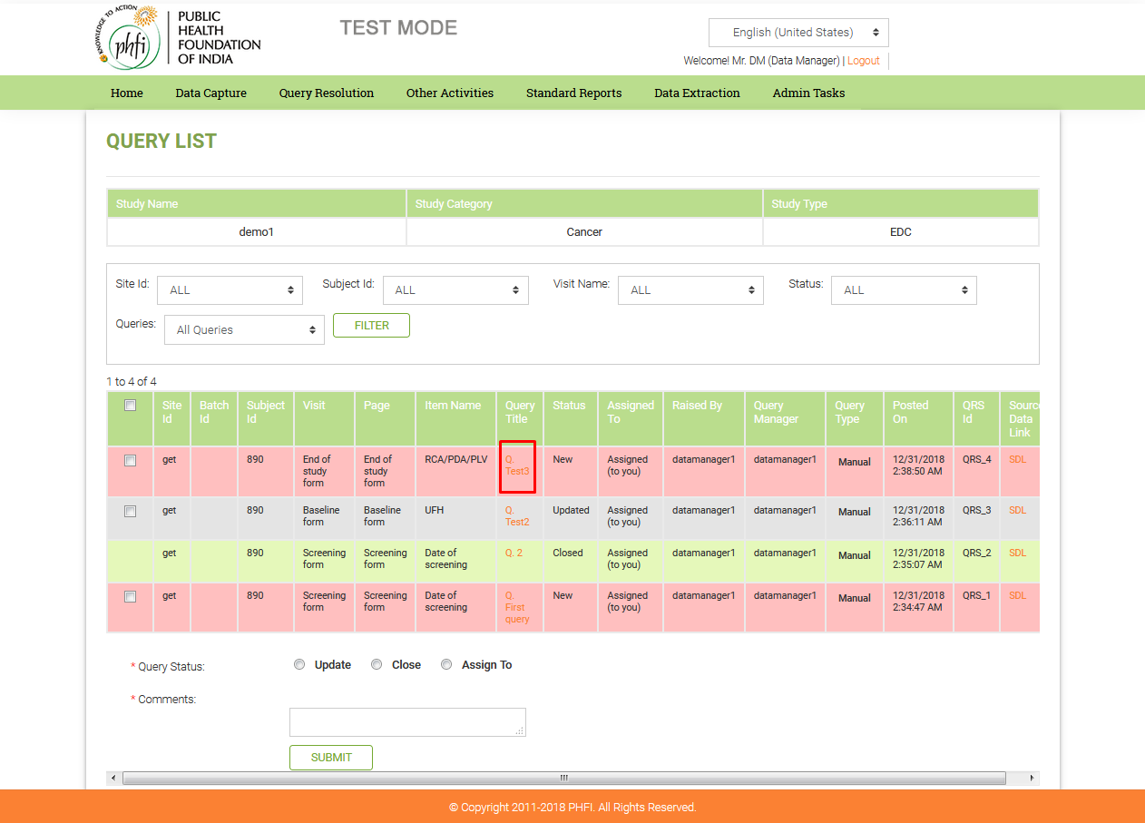

Figure 4.1: Query List Page (Query Title)

* To navigate to the eCRF where the query got raised, the Data Manager can click on SDL (Source data link) link available next to each query.

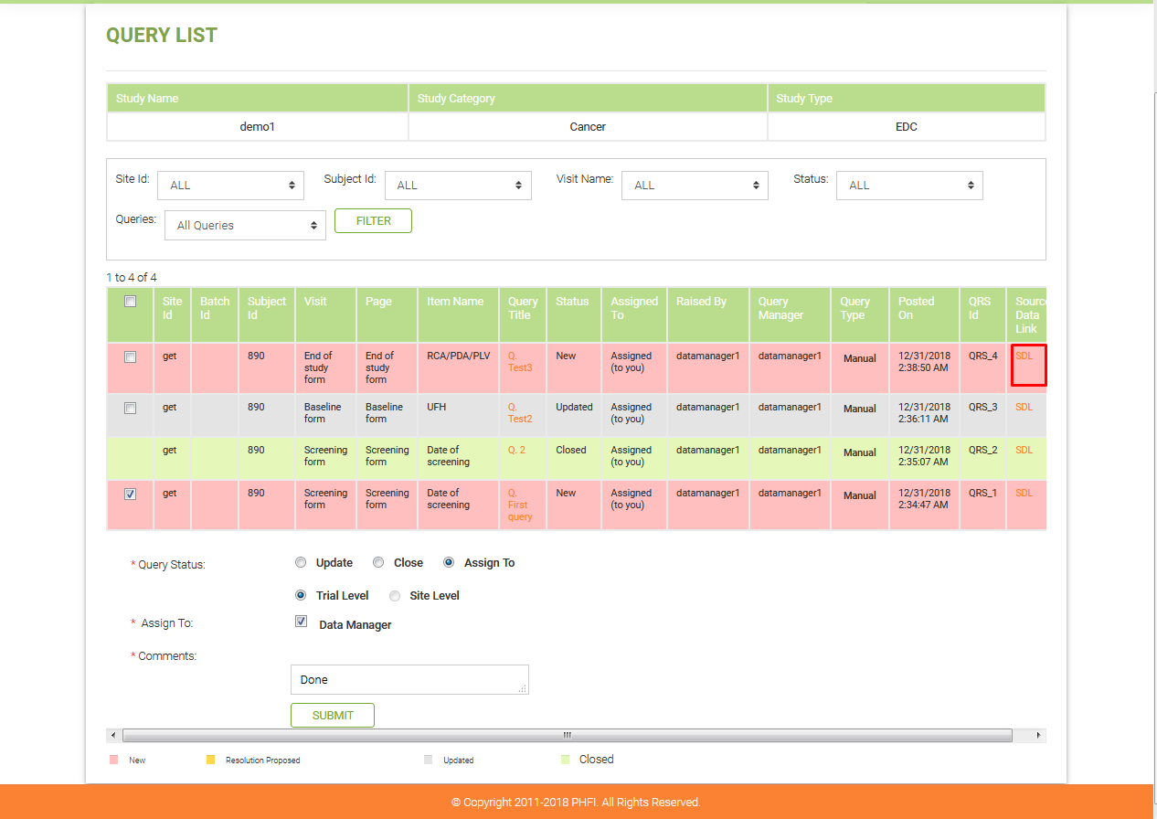

Figure 4.2: Query List Page (Source data link)

* **QUERY TITLE LINK**: On selecting this link, a page with the query details would appear on the screen. The data manager would have the option to reply (if it is resolution proposed) or Assign it to the Site level personnel, if it’s a new query.

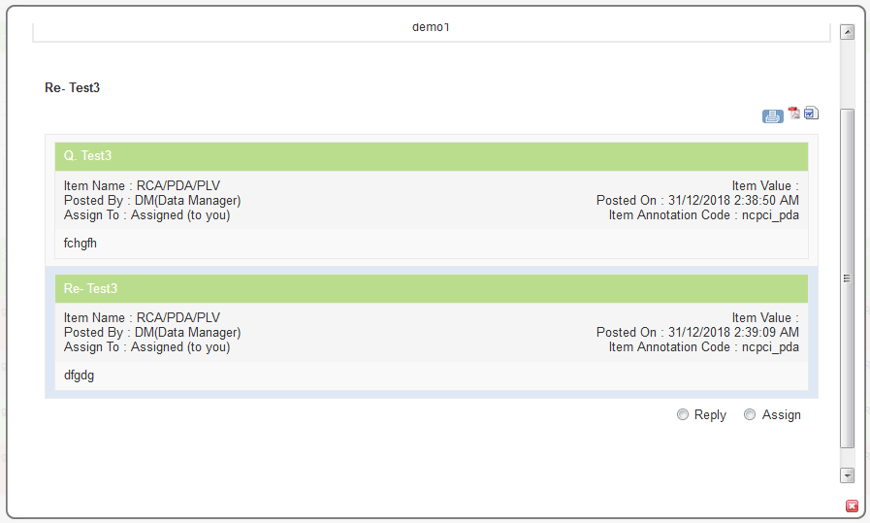

Figure 4.3: Query List Page (Query)

* **Reply:** On selecting the Reply option, the data manager would have to enter the Description in the text area, which is mandatory. After the description has been entered, the Data Manager can either Update the Query or Close it.

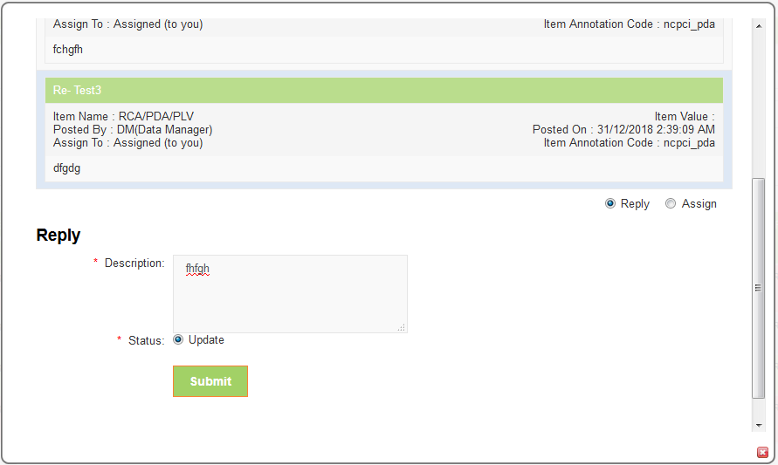

Figure 4.4: Query List (Reply to Query)

* **Assign:** On selecting the Assign option, the data manager would have to enter the description in the text area provided and select Trial or Site level so that the query is assigned to any of the roles that were assigned in the DCF workflow.

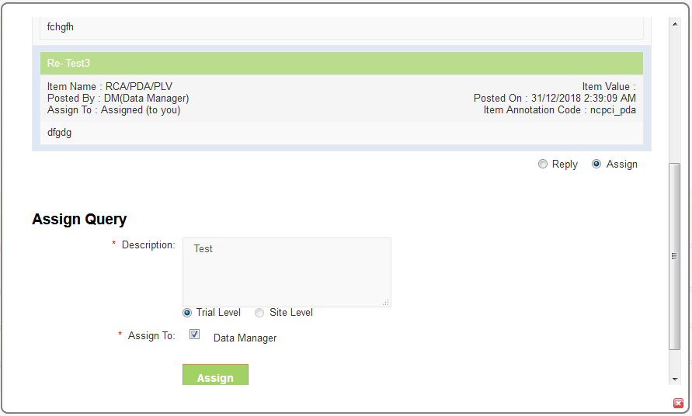

Figure 4.5: Query List (Assign the Query)

* **SOURCE DATA LINK**: If the Data Manager clicks on SDL, they would be directed to the eCRF page where auto query was generated. The field for which the query was raised, would appear red in color and in the same data field, a yellow colored query icon would be seen. On selecting the yellow icon, a page would appear wherein the data manager would be able to see the details of the query, which are the same as those seen in case of Query title link. The page also has options to Reply and Assign the query. This page would also provide the data manager with the option to raise a manual query, which has the following fields:

1. Subject, CRF, Pl Name, Item Name, Item Value (towards the left)
2. Event, Protocol ID, Item Annotation Code (towards the right)
3. Title (mandatory) with text area
4. Description (mandatory) with text area
5. Action Required (mandatory) with text area
6. Trial Level icon and Site level icon, which would enable the datamanager to assign it to a particular role/s in the selected level.
7. Once the Datamanager clicks on submit, the query icon in that data field turns red in color, from yellow. The data manager can raise multiple queries for the same data field on selecting the same query icon.

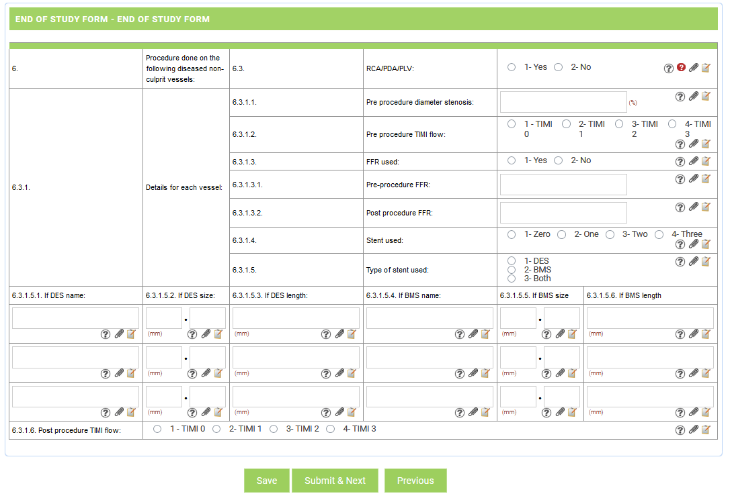

Figure 4.6: SDL (e-CRF page)

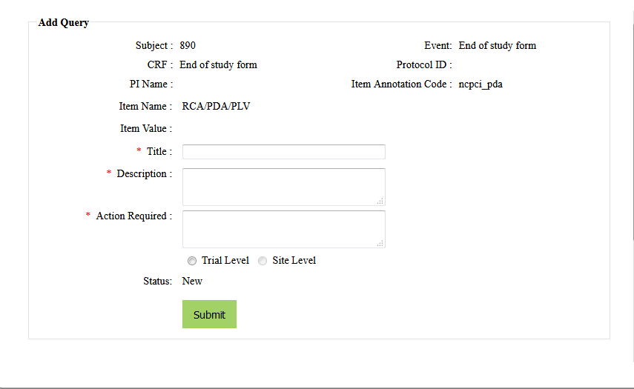

Figure 4.7: Query Page

* Each of these eCRF pages which the data manager is directed to, on selecting SDL, is provided with the Print Icon towards the top right corner of the page.
* Next to each data field, there are Add notes and Add files Icons.
* The data manager can upload multiple files (maximum size of each file, 10 MB), for each data field.

### 4.3.1 Raising Manual Queries

**Features:**

* Data Manager can raise Ad-hoc Queries for any data item in a particular eCRF of the subject.
* Data Manager can assign the query to any concerned study role by filling up the Data Clarification Form (DCF)

**Workflow:**

* In order to raise a Manual Query, the Data Manager clicks on Raise Query menu item from Query List menu in the header.

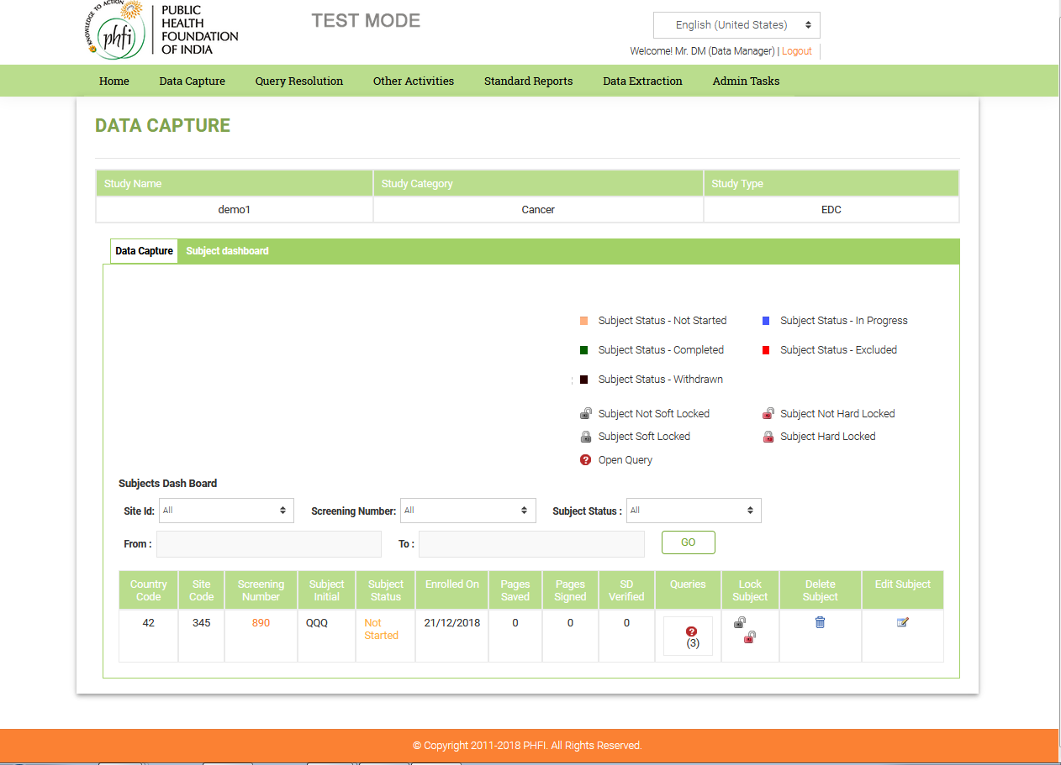

Figure. 5.0: Raise Query – Subjects Dashboard

Subjects Dashboard is displayed to the Data Manager with the list of subjects in different sites.

* By clicking on the subject, a Pop-up is displayed with all the available visits.

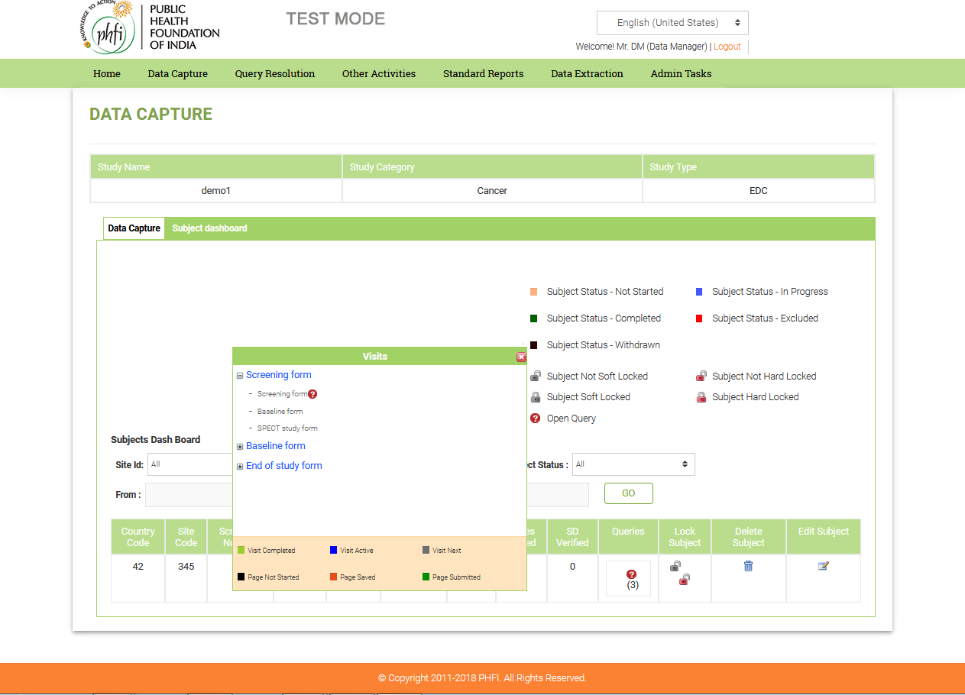

Figure 5.1: Raise Query - Visits

* When the Data Manager clicks on the Visit name, all the eCRFs available in the visit are displayed.
* Legends are displayed for all the different statuses of Visits and Pages in the bottom of the Visits popup.
* The query icon beside the page name resembles that the eCRF page contains open queries whereas the ‘IV’ icon denotes that the respective page is investigator verified.
* By clicking on any of the eCRF pages, the Data Manager is navigated to the respective eCRF page.
* Data Manager can raise Ad-hoc Query against any Data Item in CRF by clicking the white question mark icon displayed next to each data item.

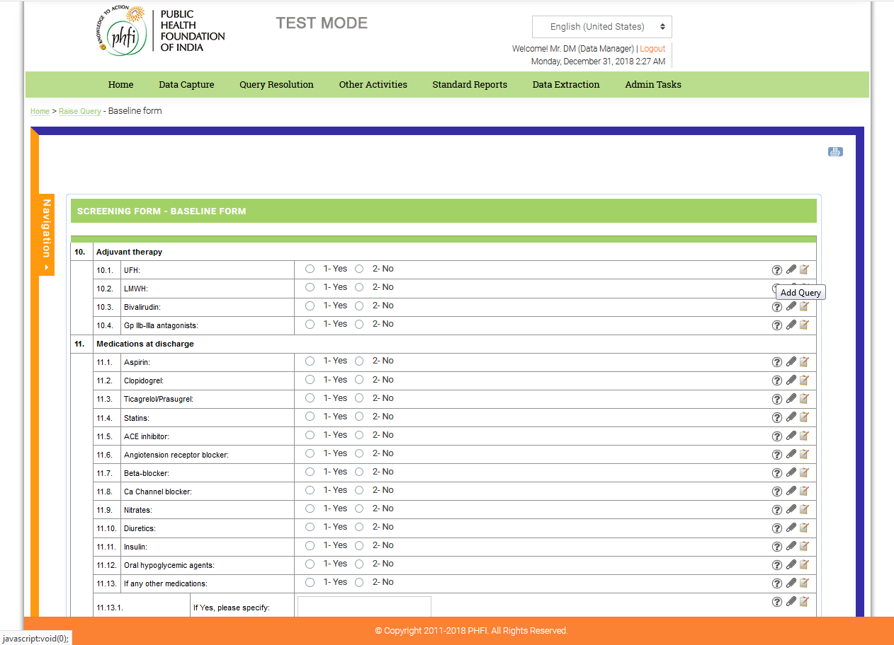

Figure 5.2: Raise Query – Question Mark Icon

* A Data Clarification Form is displayed, where Data Manager can provide Title, Description, Action required and assigns the query to concerned study role along with Priority.

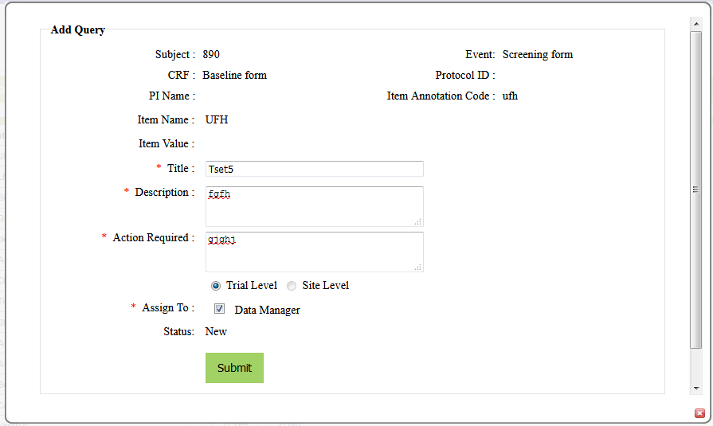

Figure 5.3: Raise Query – Data Clarification Form

* The Data Manager can assign the query to a particular study role as per the defined query workflow.
* After submitting the form, the query is raised in the eCRF page. A red query icon is displayed in the eCRF page and a query is added to the query list.

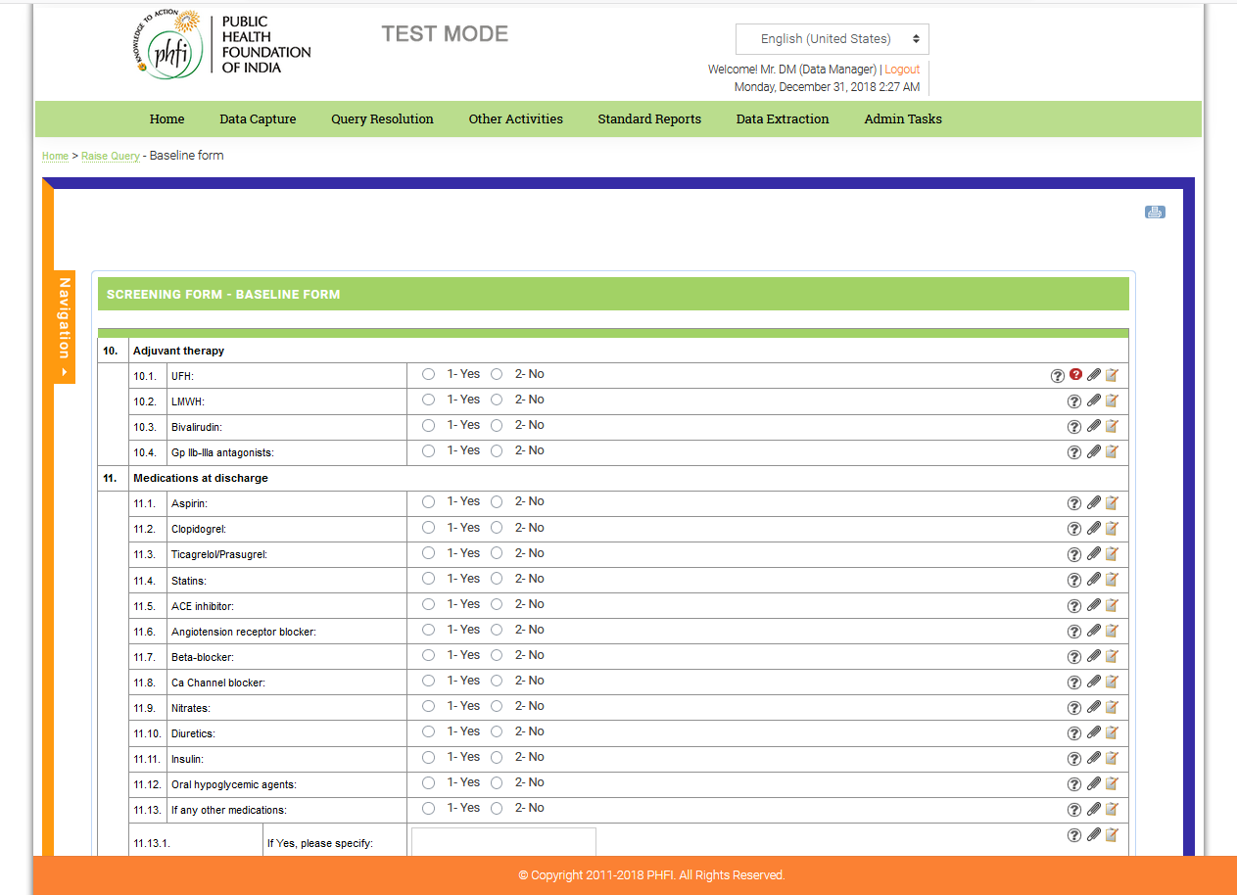

Figure 5.4: Raise Query – Query Icon turns Red in color

### 

## 4.4 Standard Reports

**Features:**

* The system offers 4 Standard Reports that are available to the Data Manager.
* Query Ageing Report
* Query Count by Subject
* Site Summary Report
* SDV Status Report
* The Data Manager can print the reports by clicking on the Print icon available on the page.
* The reports can be extracted to excel and PDF formats by clicking on the respective icons displayed on the page.
* The Data Manager can filter the sites or view the reports of all the sites, by using the filter option.
* **Query Ageing Report** has the following details:

1. Site ID
2. Subject
3. Visit Name
4. Query Description
5. Query date
6. Query Updated Date
7. Ageing Period (Days): If the queries exceed the days limit which was configured in the query workflow, they appear Red in color.

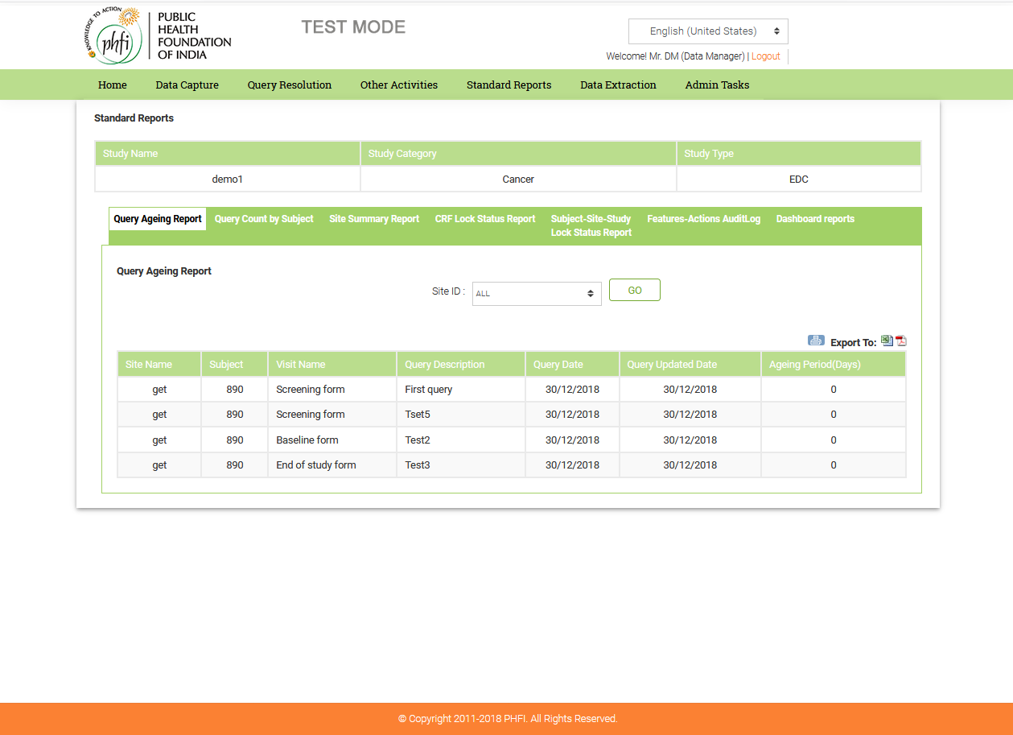

Figure.6.0: Standard Reports – Query Ageing report

* **Query Count by Subject** has the following details:

1. Site ID
2. Subject
3. Visit Name
4. Page Name
5. No. of Open Discrepancies
6. No. of Closed Discrepancies
7. Total No. of Discrepancies

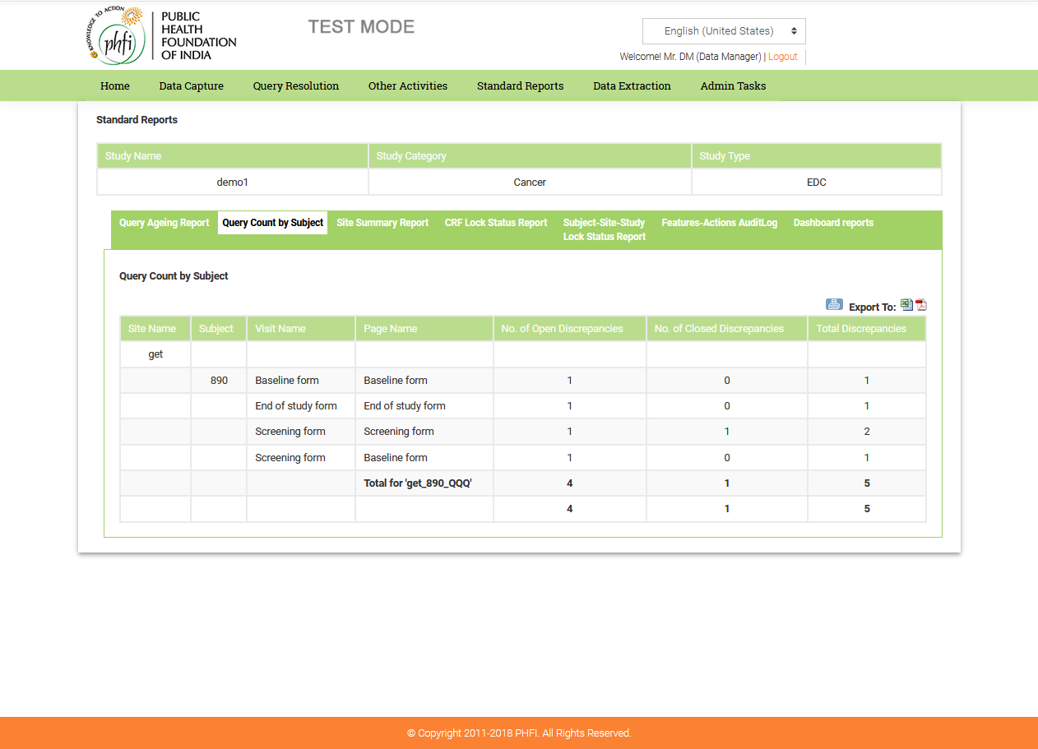

Figure.6.1: Standard Reports – Query Count By Subject

* **Site Summary Report** has the following details:

1. Site ID
2. No. of eCRF’s entered
3. No. of Queries Raised
4. No. of Open Queries
5. No. of Closed Queries

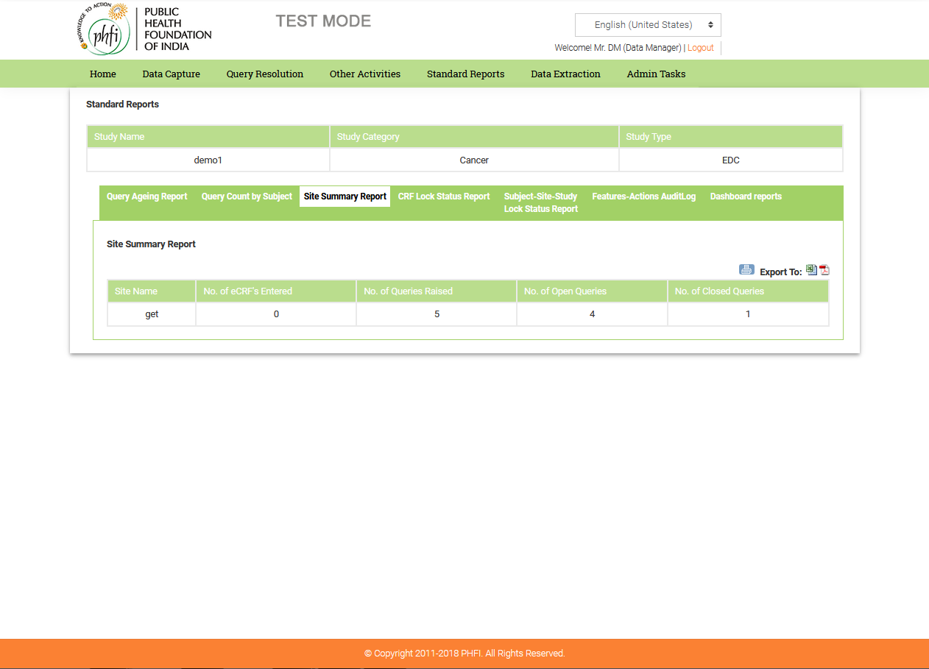

Figure 6.2: Standard Reports: Site Summary Report

* **SDV Status Report** page has filter options for Sites, Subjects, Page Status and SDV Status. The other details presented in the table are as follows:

1. Site ID
2. Subject
3. Visit Name
4. Page Name
5. Page Submitted
6. SDV Status

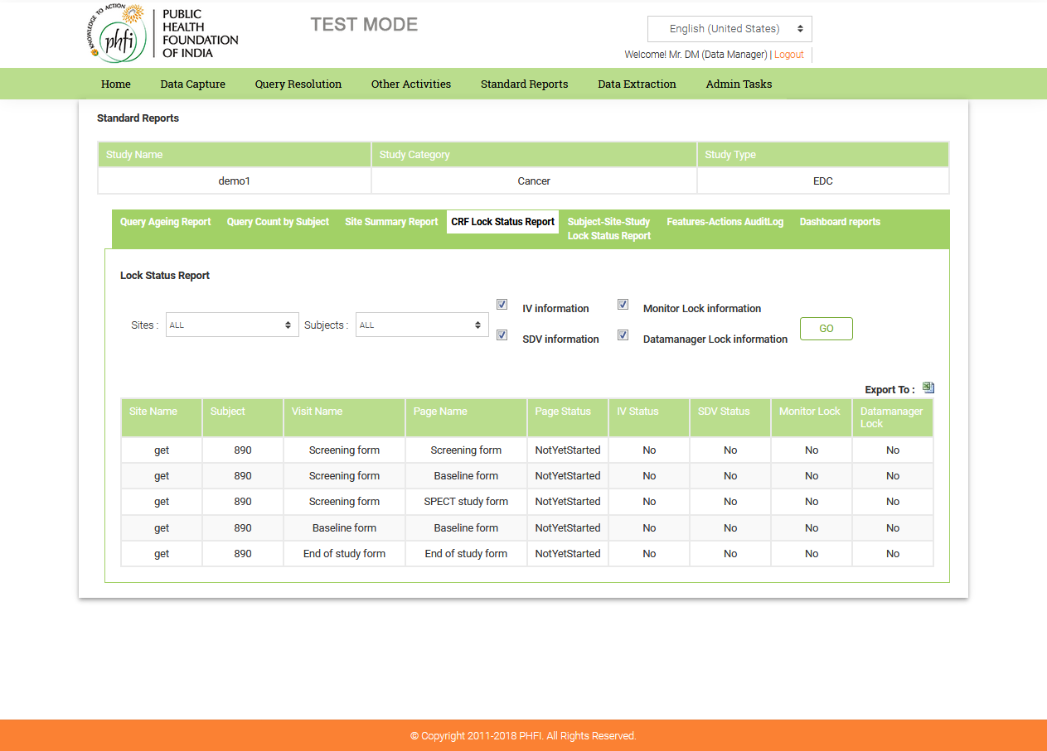

Figure 6.3: Standard Reports: SDV Status Report

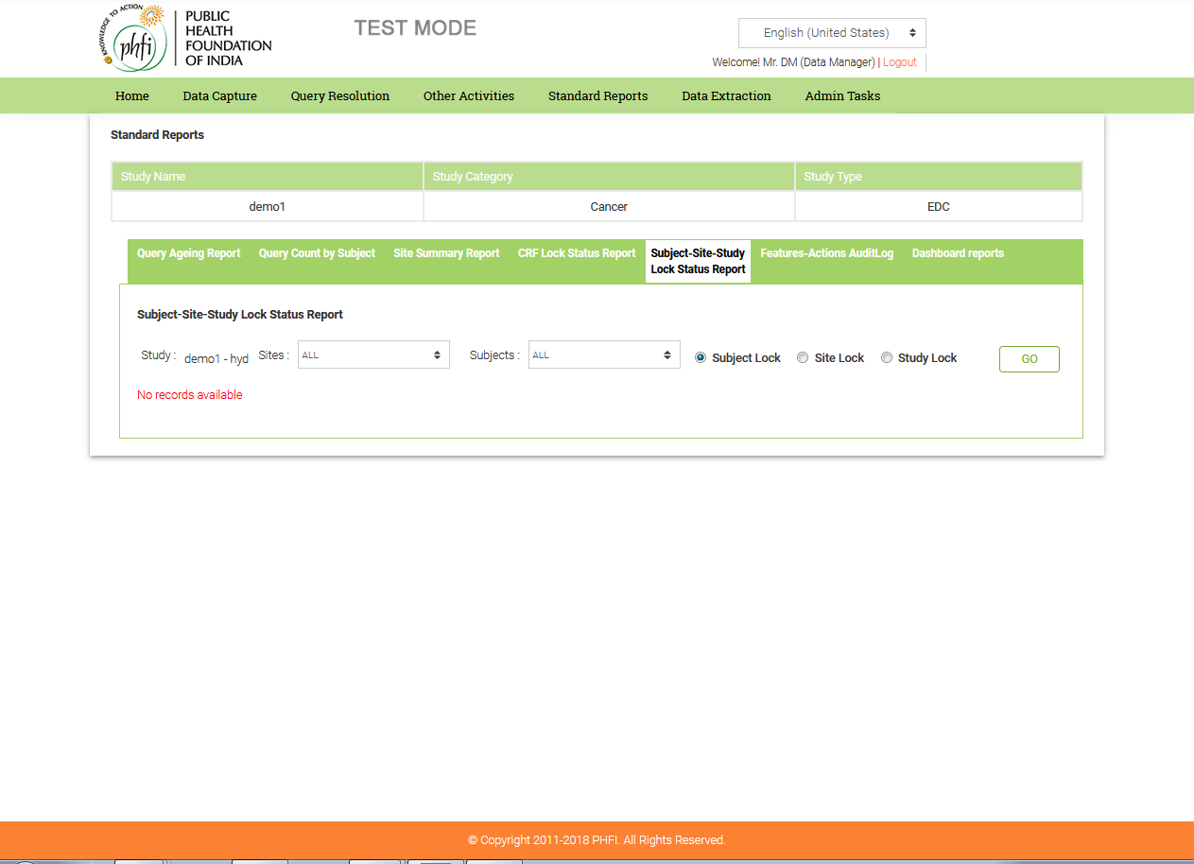

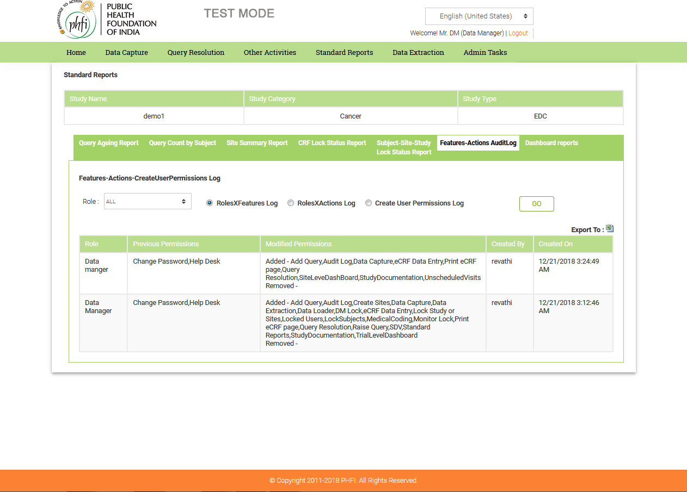

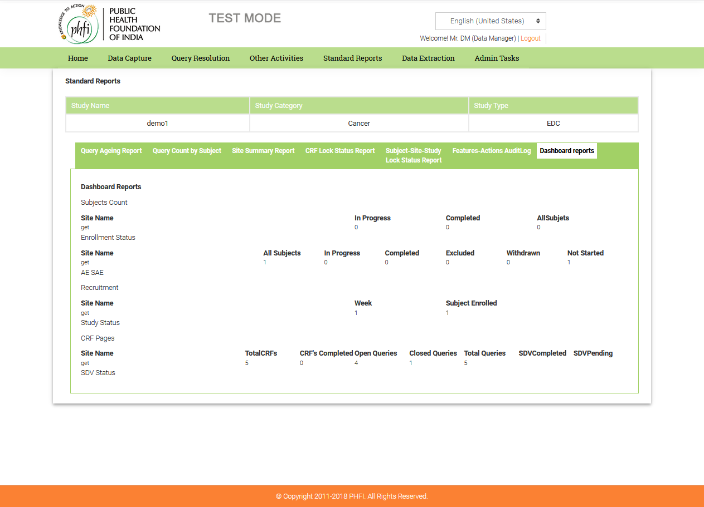

## Data Extraction

* Data Manager can extract the complete data in the eCRFs.
* The application permits 7 types of Data Extractions that are available to the Data Manager.

1. CRF Data Extraction.

2. Notes Extraction

3. Attachments Extraction.

4. Medical Coding Extraction

5. CRF Book Extraction

6. Annotation CRF Book Extraction

7. QRS Extraction

CRF Data Extraction: Data Manager can extract CRFs:

1. Per Panel,
2. Per Dynamic Screen,
3. Unscheduled Visits page,
4. Page wise data extraction

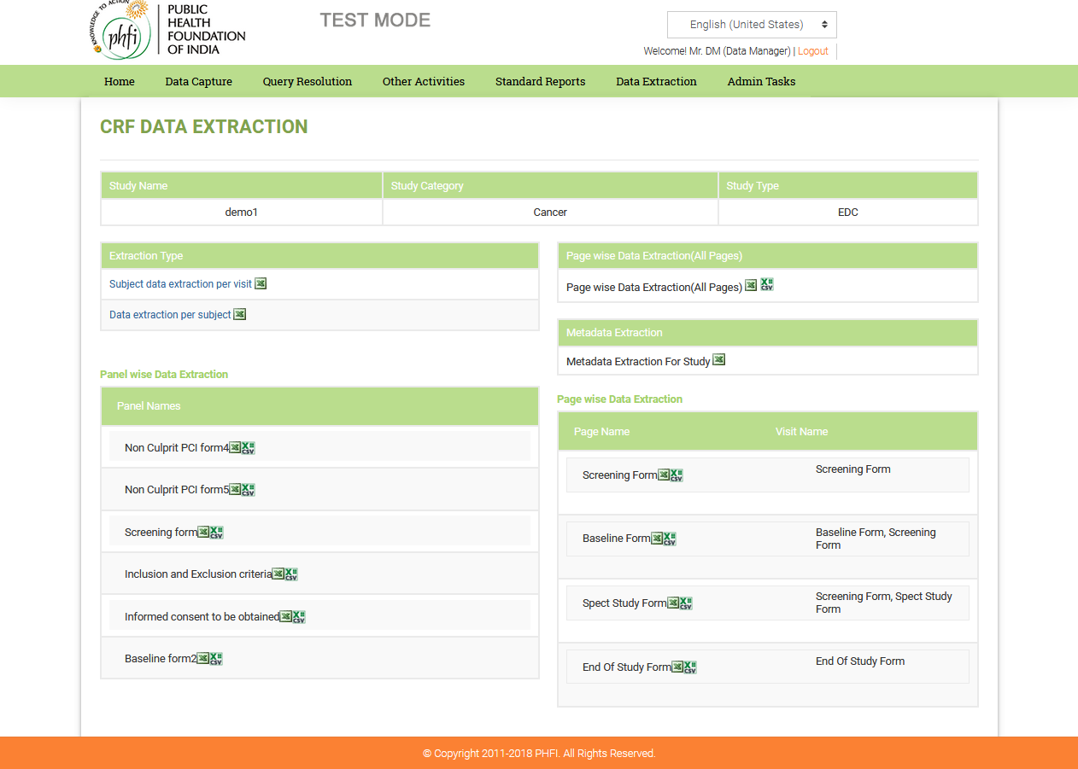

Figure.7.0: Data Extraction – CRF Data Extraction

* **Notes Extraction:** The Data Manager can extract the complete notes entered in the eCRFs, Page wise and Visit wise.

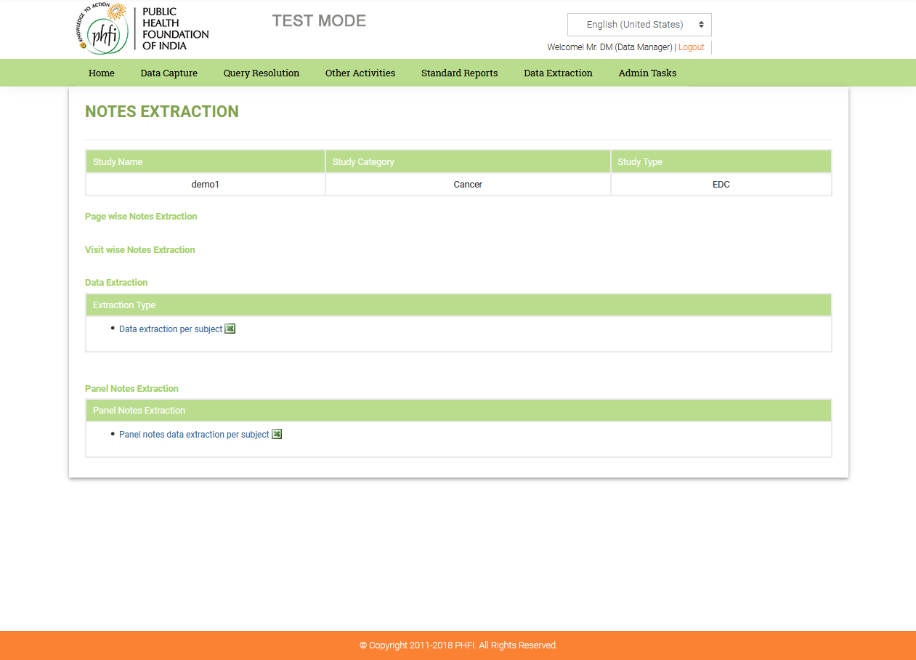

Figure 7.1: Data Extraction – Notes Extraction

* **Attachments Extraction:** Data Manager can extract all the Attachments in the CRFs of all the sites.
* **Medical Coding Extraction:** Data Manager can extract complete list of Medical coding done, both for Adverse Event terms and Concomitant Medication terms.

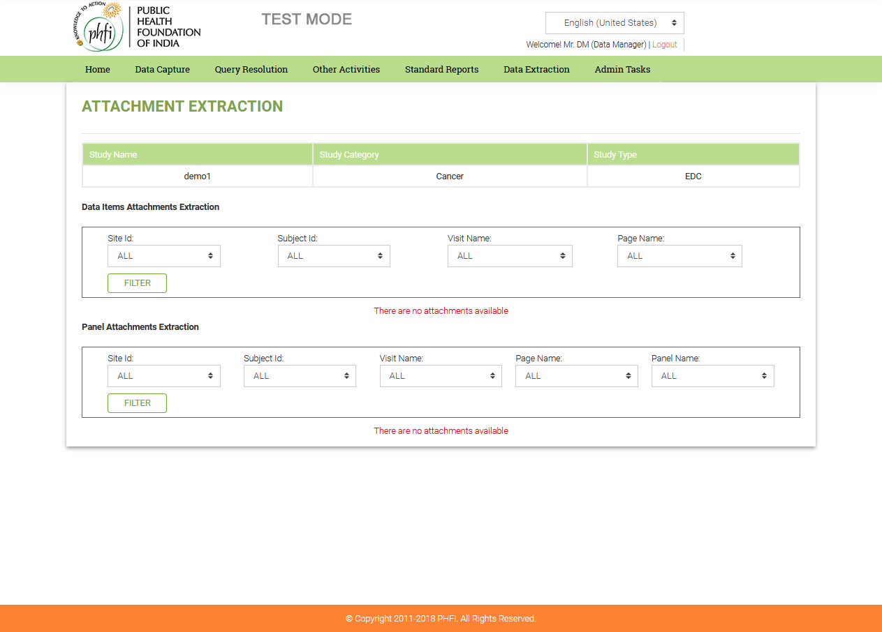

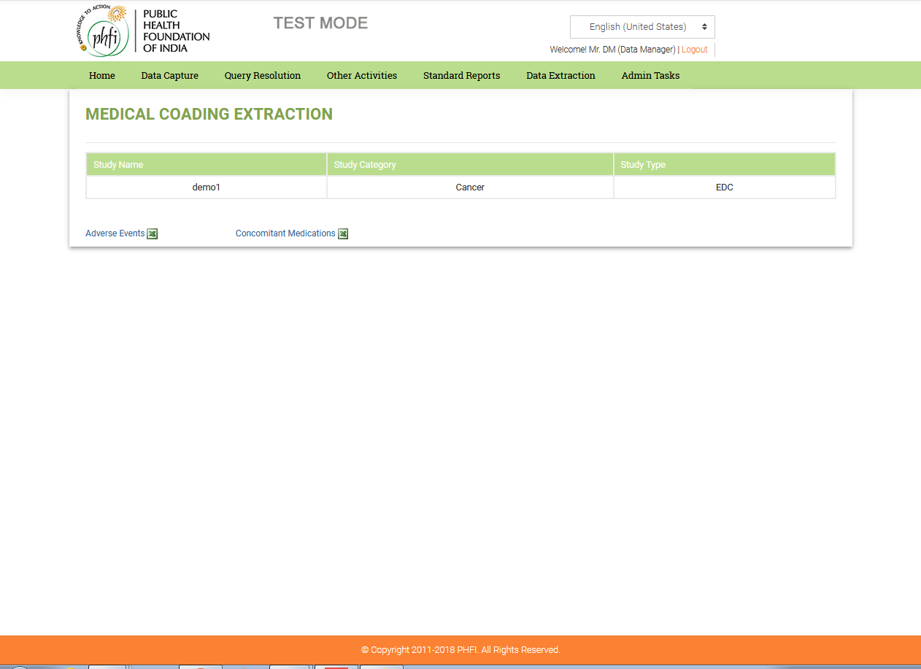

Figure 7.2: Data Extraction – Medical Coding Extraction

* **CRF Book Extraction:** Data Manager can extract the CRF Book for a particular subject and site by filtering and by clicking on Generate CRF.

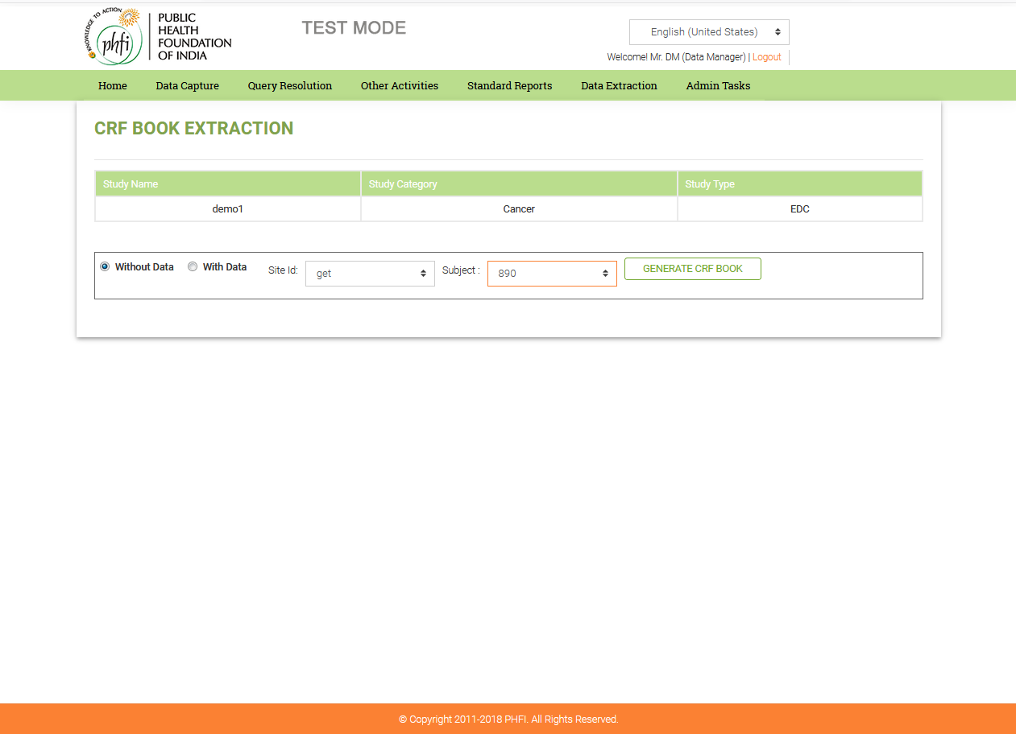

Figure 7.3: Data Extraction – CRF Book Extraction

* **Annotated CRF Book Extraction:** Data Manager can extract the annotated CRF Book for a particular subject and site by filtering and by clicking on Annotated CRF Book, button.



Figure 7.4: Data Extraction – Annotated CRF Book Extraction

* **QRS Extraction:** Data Manager can extract the Queries, per site, subject, visit or query status and those assigned to the data manager, by using the filter option. All this information can be exported to pdf and word files.

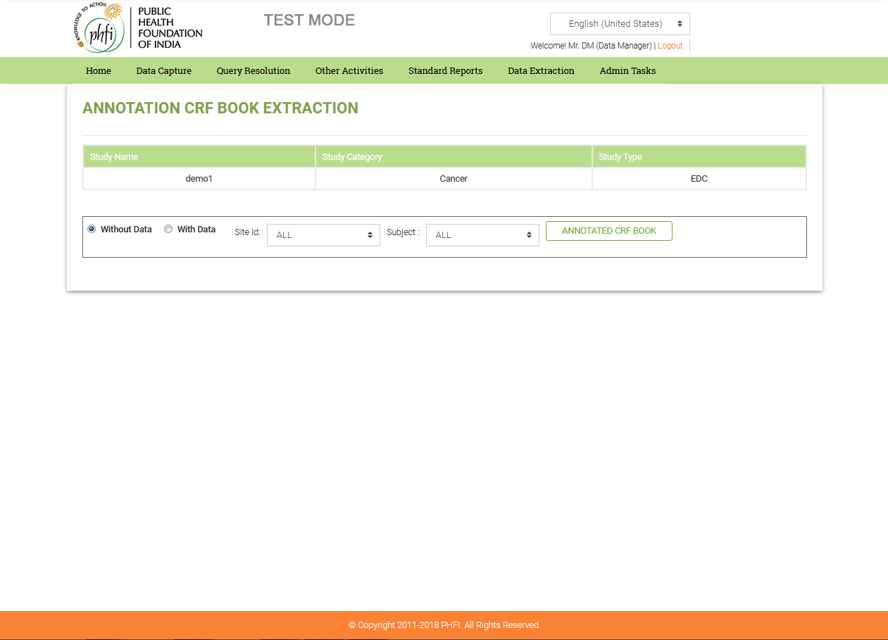

Figure 7.5: Data Extraction – QRS Extraction

## 4.6 Audit Log (Other Activities)

**Features:**

The Audit log captures the Data Item value changes and all the system activities.

* Data Manager has option to view Data Log and Activity Log.
* In the audit log, the changes against any Data Item are captured.
* All the information on the Audit log page can be exported to pdf file.

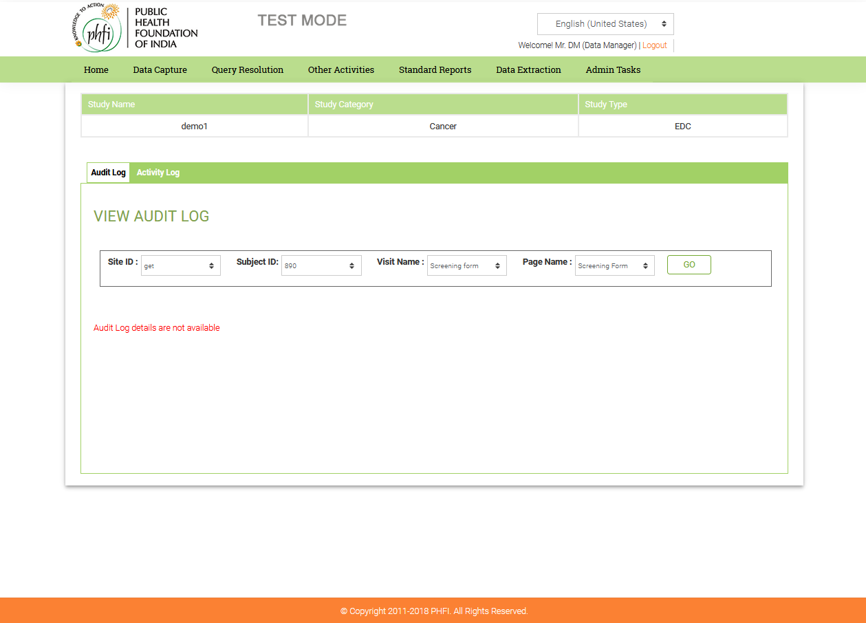

Figure 8.0: Audit Log – View Audit Log

**Workflow:**

* The Data Manager clicks Audit Log that displays the audit log section by default.
* The audit log section displays the Visit name, Form Name, Old value, New value, Reason for the change, Modified by (user name who modified the value), and Date and Time.
* Data Manager has an Option to filter audit log according to preferred Site, Subject or Visit.

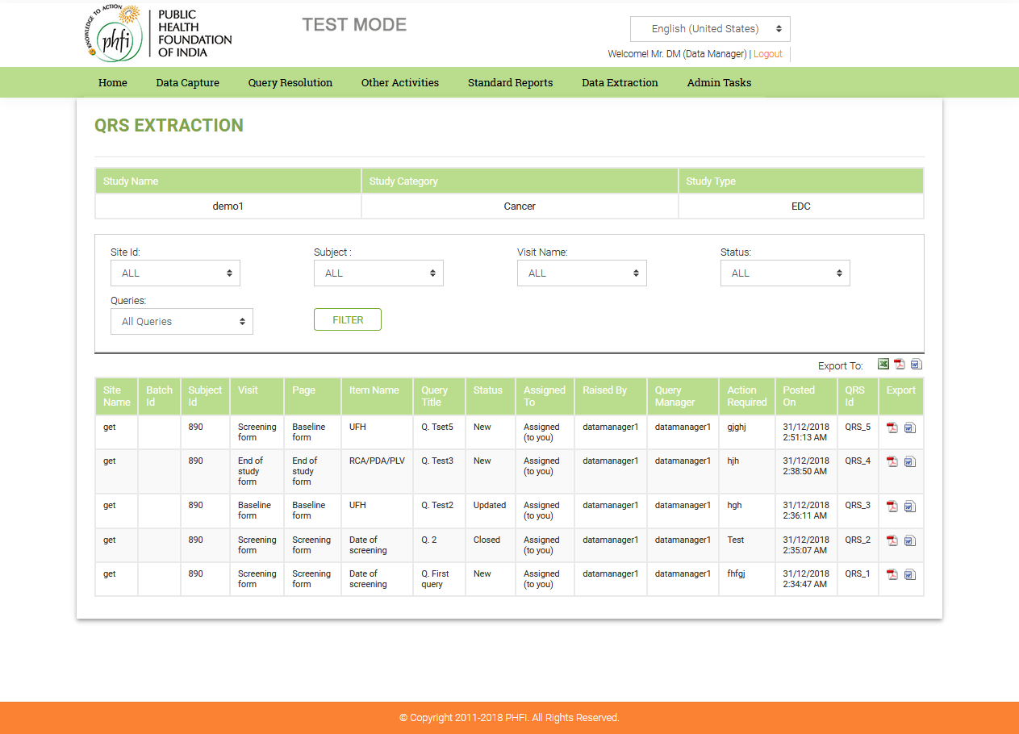

Figure 7.1: Audit Log – Activit Log

* When Data Manager clicks on Activity log, a list of all the activities done on the system is displayed along with the User, Activity, Date & Time, IP address of system

## 

## 4.8 Lock Study / Site( Other Activites)

**Features:**

* The Data Manager can lock the Study or Sites at any point of time.
* The Data Manager can lock an individual site or can lock all the sites at a time.
* The Data Manager can unlock the sites or study once they are locked.

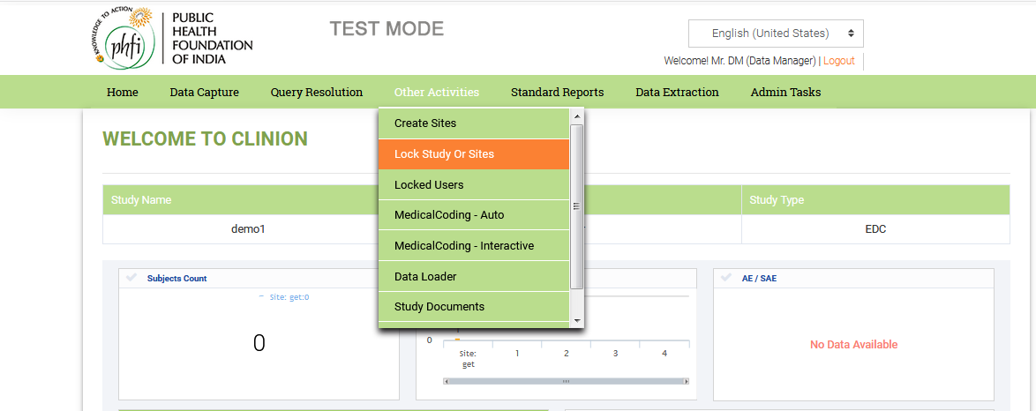

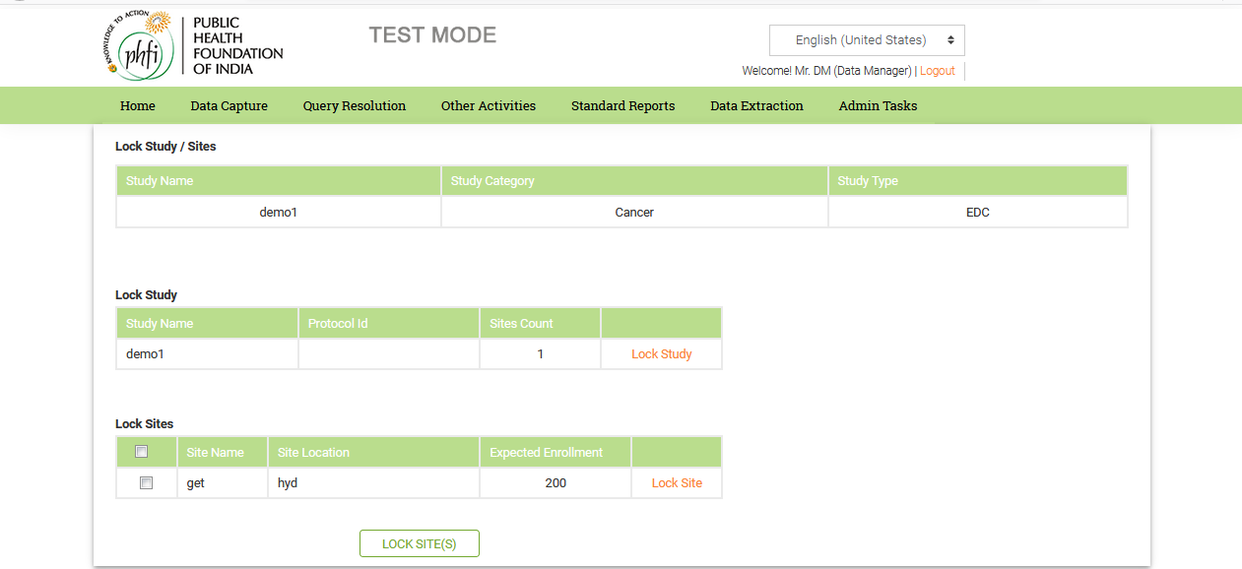

Figure 8.0: Lock Study/Sites

## 4.9 Create Sites ( Other Activites)

**Features:**

* The Data Manager creates Sites by providing the required details in the Create Sites page.
* All the created sites are displayed in the same page where there is an option to manage the sites’ information.

**Workflow:**

* By clicking on Create Sites menu in the footer, Data Manager can create a new site by providing the required fields:

1. Country (mandatory): Once the country is entered, country code, site code, site name and location are auto populated.
2. Address
3. Phone
4. Select Time Zone (mandatory): Data manager has the option to keep the study time zone applicable, by selecting the check box, ‘Keep Study Time Zone’, above Time Zone drop down box.
5. Expected Enrolment (mandatory).

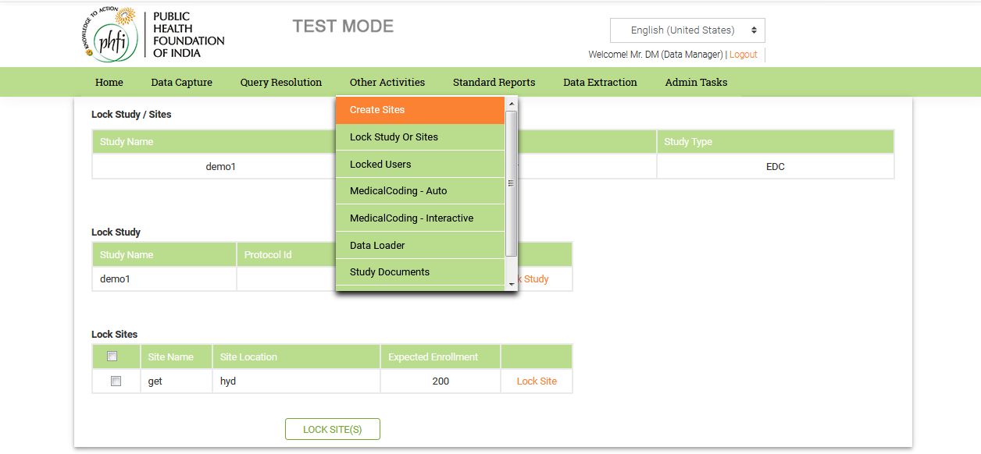

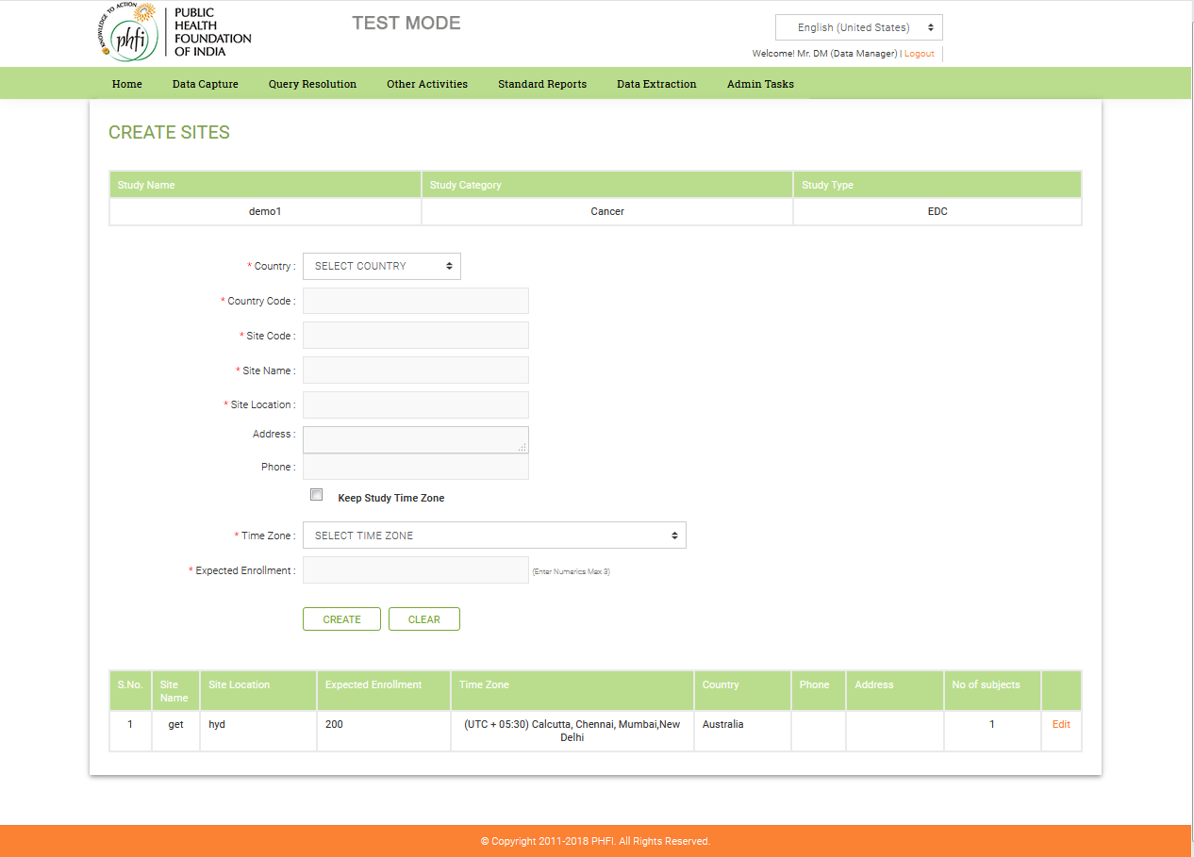

Figure 9.0: Create Sites

* Data Manager can also edit the existing Sites Information by clicking on ‘Edit’ option available in the Sites table next to each site.

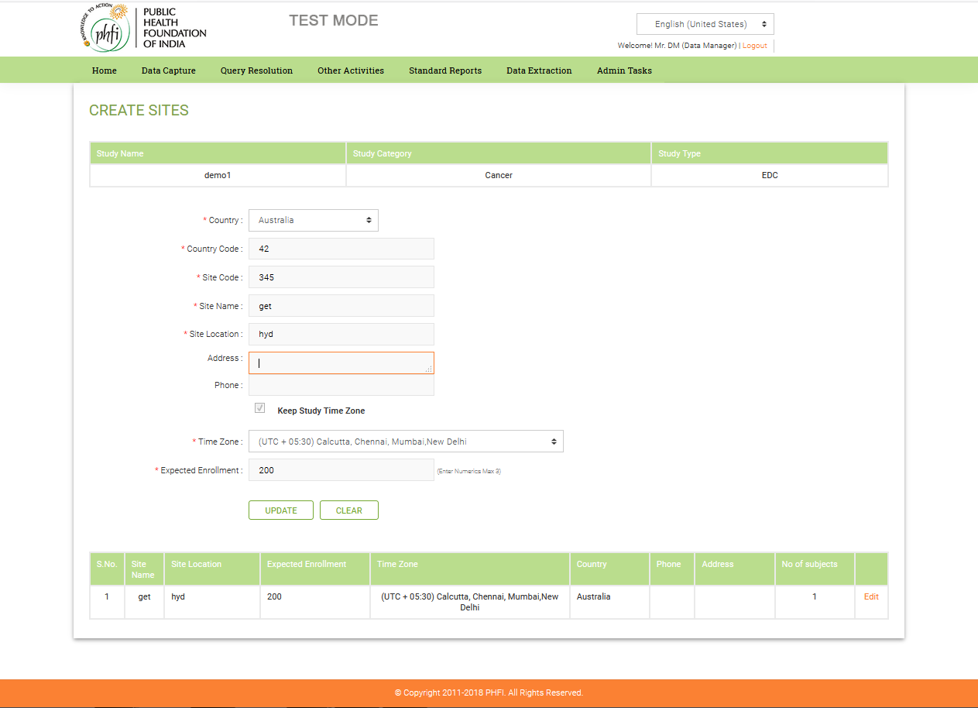

Figure 9.1: Create Sites (edit option)

## 4.10 Medical Coding(Other Activites)

**Features:**

* Data Manager has option to run Medical Coding on Adverse event terms and Concomitant Medication terms with Auto and Interactive options.
* In Auto Coding, the system automatically matches the terms and displays the respective LLT, PT, HLT, HLGT and SOC.
* If the system has multiple matched terms in the dictionary, the respective terms are not auto coded are left for the user to do Interactive Coding on such terms.

**Work Flow:**

* Data Manager goes to Medical Coding and clicks Auto link where Data Manager can select AE log/ Con-med log.

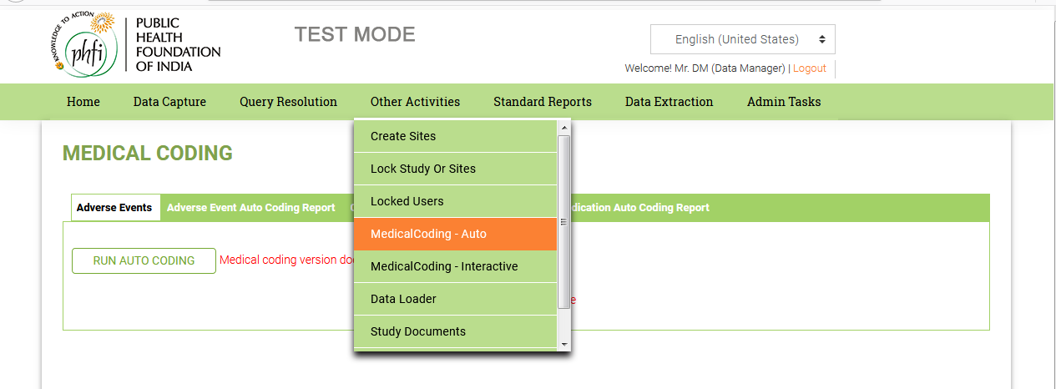

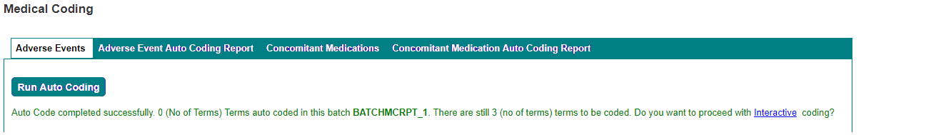

Figure 10.0: Medical Coding (Adverse Events)

* Data Manager has the option to Run Auto Coding. On the Medical coding page of both, AE and Concomitant medications, the data is presented with Batch ID, Date and Time, Coded By, Dictionary and View Report. The Reports for both AE and concomitant medications are links. Once the View Report linked is selected, the AE report page and the Concomitant Medications Report page, opens.

Click on Interactive to continue with Interactive coding.

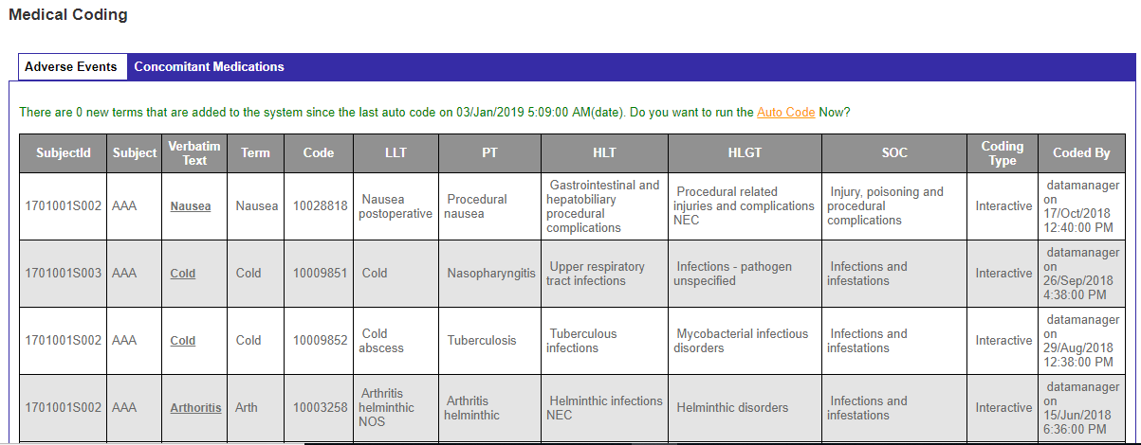

Medical Coding ( Interactive)

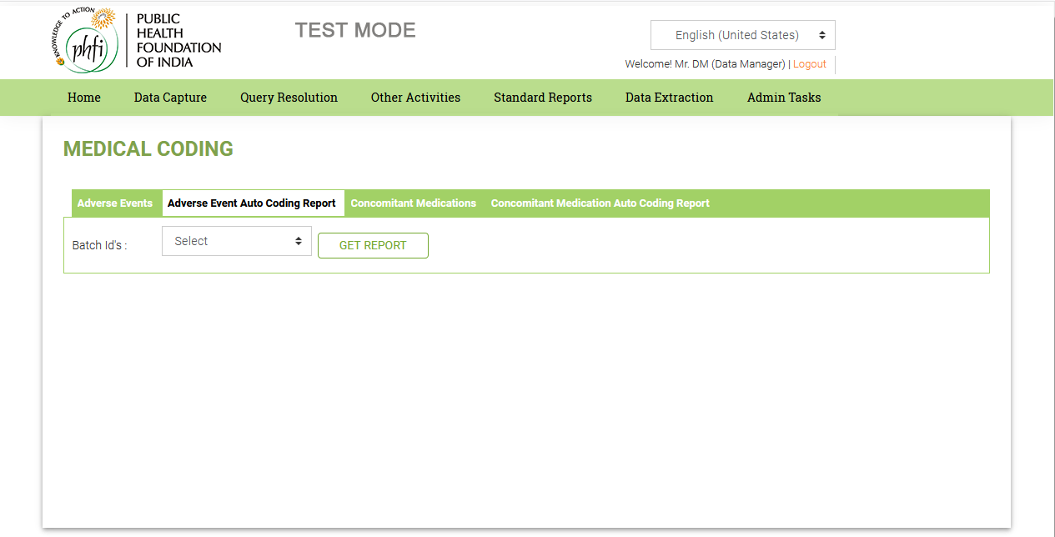

Figure 10.1: Medical Coding: Auto Coding (Adverse Event Report)

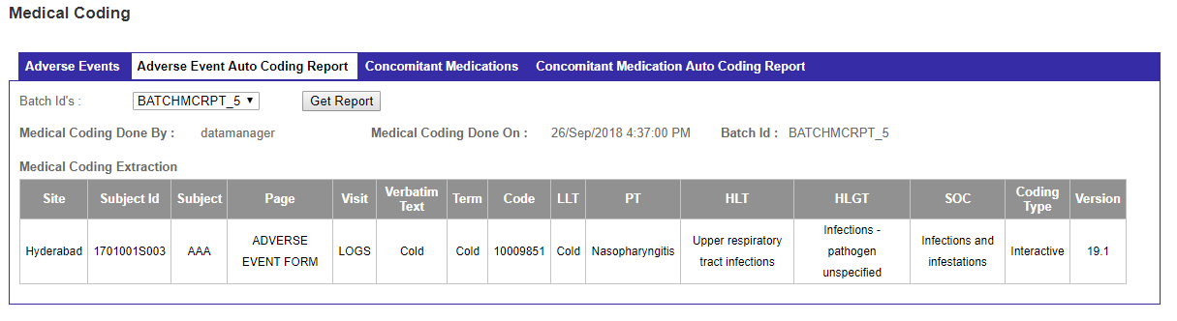

Figure 10.1(b): Medical Coding: Auto Coding (Adverse Event Report)

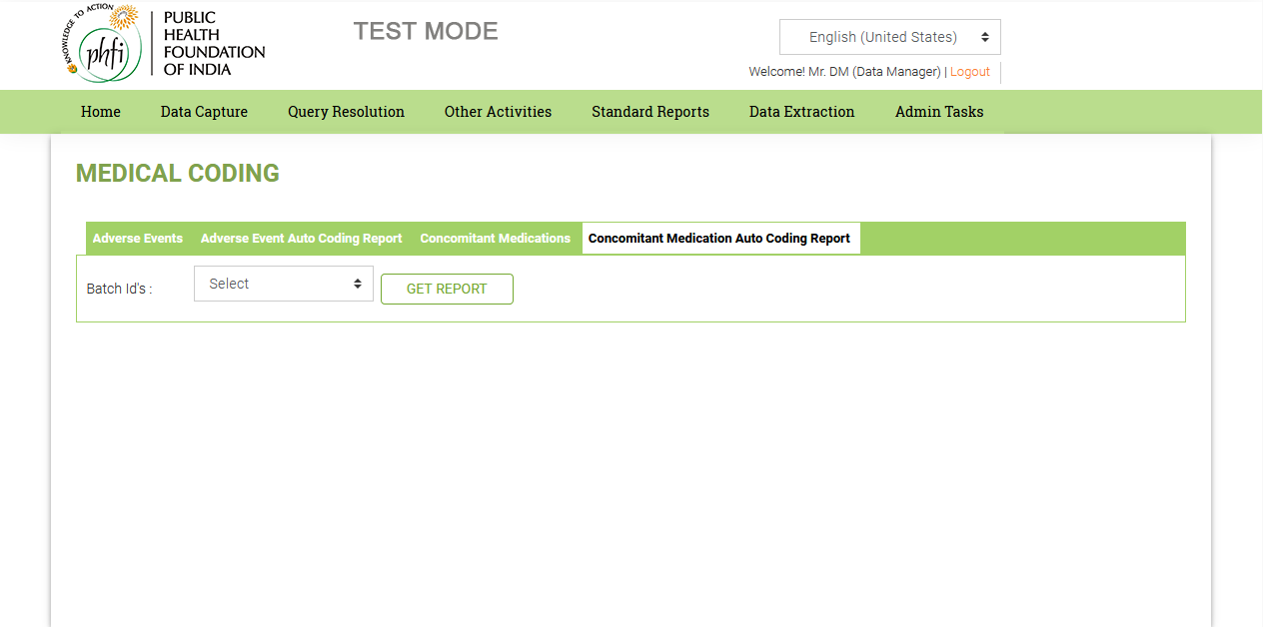

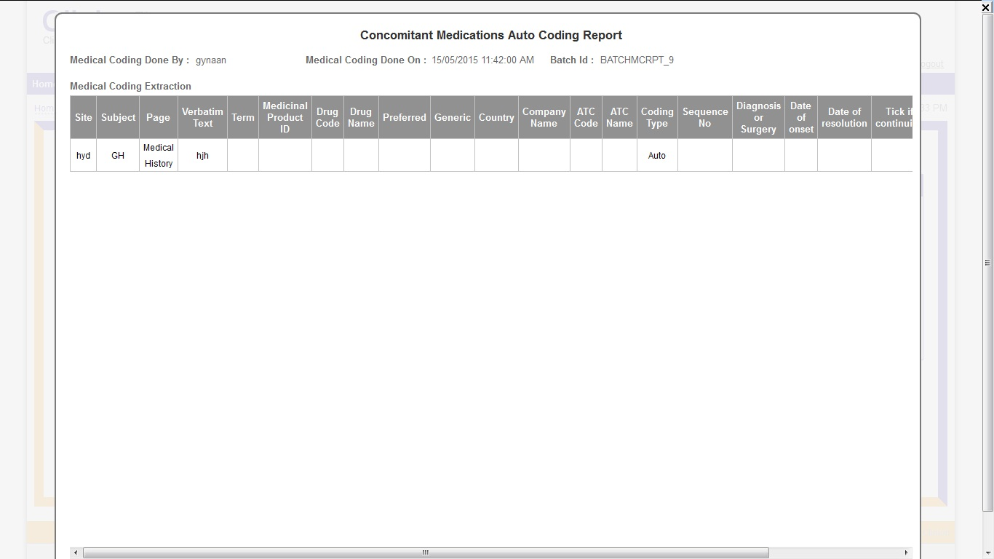

Figure 10.2: Medical Coding: Auto Coding (Concomitant Medications)

* The terms which are not auto coded can be done through the interactive way. Data Manager selects interactive from the footer menu of Medical Coding.
* Data Manager selects AE log or Con-med Log from the dropdown to perform Interactive coding.
* Data Manager clicks on the verbatim text to do Interactive Coding for the respective term.
* The selected ‘Verbatim Text’ is displayed in the Textbox. The Data Manager clicks on the required button to do Interactive coding.

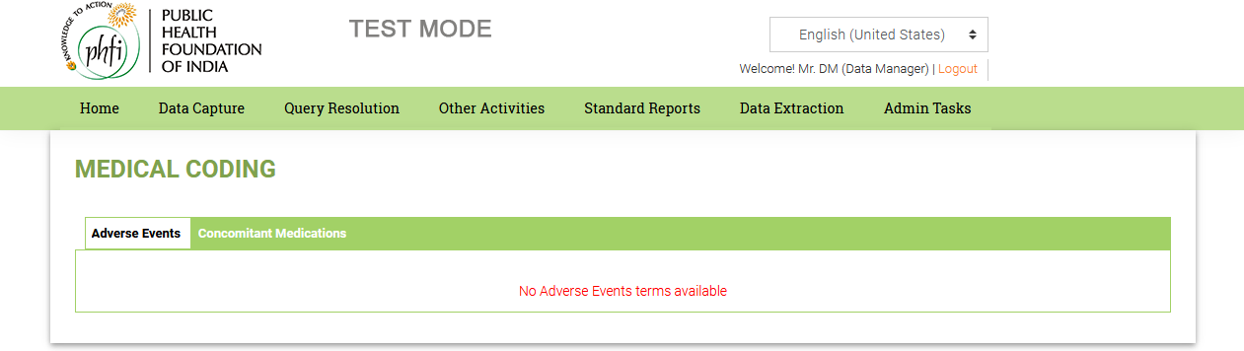

Figure 10.3: Medical Coding (Interactive)

* Data Manager can accept any of the terms from list of terms displayed.

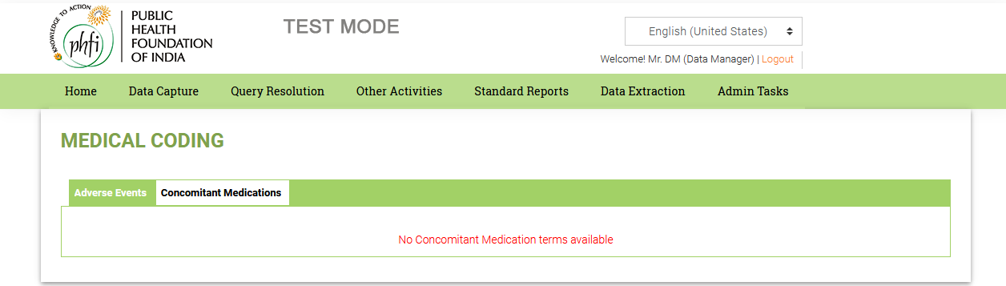

Figure 10.4: Medical Coding (Interactive)

* When the Data Manager clicks on ‘Accept’, the term is Interactive Coded and all the LLT, PT, HLT, HLGT and SOC terms are displayed along with the coding type.

## 4.11 Admin Tasks

**Features:**

* The Data Manager can change the password by clicking on the ‘Change Password’ in the Admin tasks menu in the footer.
* Data Manager can unlock the users Locked Users by clicking on the ‘Locked Users’ in the Admin tasks menu.

**Work Flow:**

* When Data Manager selects Change Password, Data Manager can change current password and configure new password.

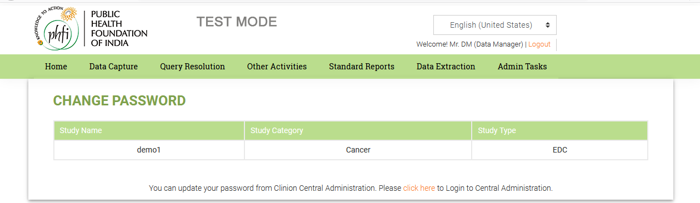

* Data Manager can unlock any Locked Users by clicking Locked users tab from Admin tasks.

